Implement Bollinger Bands - 1 Standard Deviation
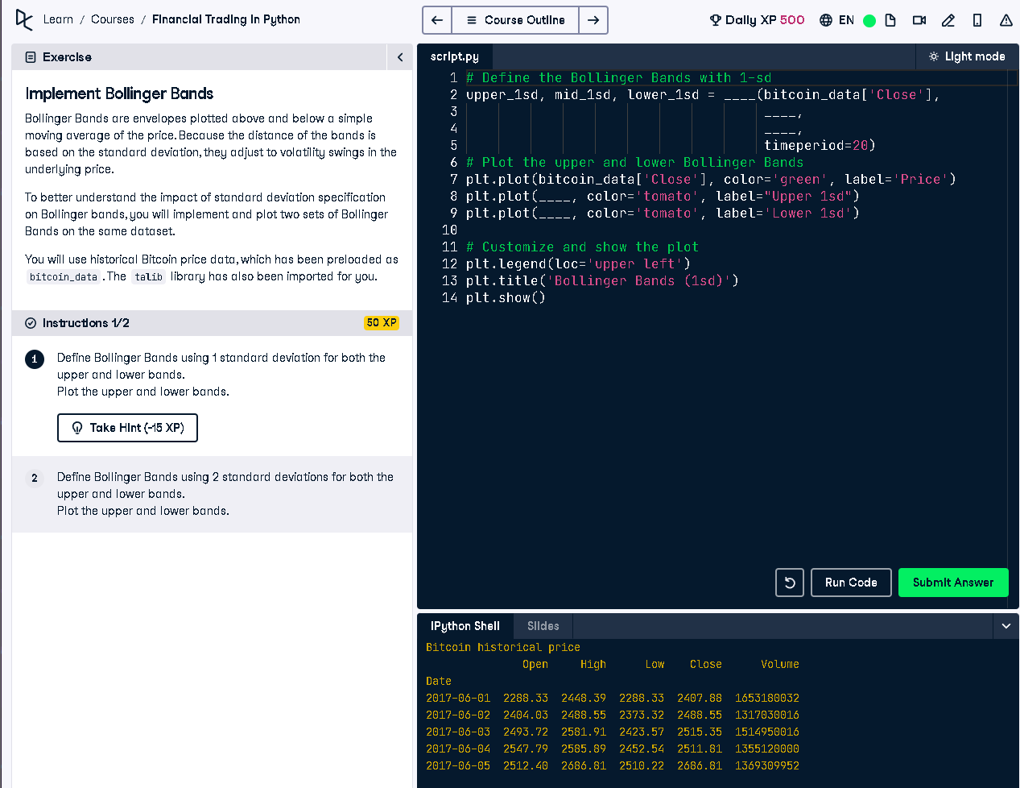

Full Python Code
# Define the Bollinger Bands with 1-sd
upper_1sd, mid_1sd, lower_1sd = talib.BBANDS(bitcoin_data['Close'],
timeperiod=20,
nbdevup=1,
nbdevdn=1,
matype=0)
# Plot the upper and lower Bollinger Bands
plt.plot(bitcoin_data['Close'], color='green', label='Price')
plt.plot(upper_1sd, color='tomato', label='Upper 1sd')
plt.plot(lower_1sd, color='tomato', label='Lower 1sd')
# Customize and show the plot
plt.legend(loc='upper left')
plt.title('Bollinger Bands (1sd)')
plt.show()

Simple Explanation (50 Words)
This script calculates Bollinger Bands using 1 standard deviation above and below a 20-day moving average. It then plots the closing price along with these bands. Bollinger Bands help identify price volatility. Narrow bands mean low volatility, wide bands indicate high volatility. They also signal overbought or oversold conditions.

